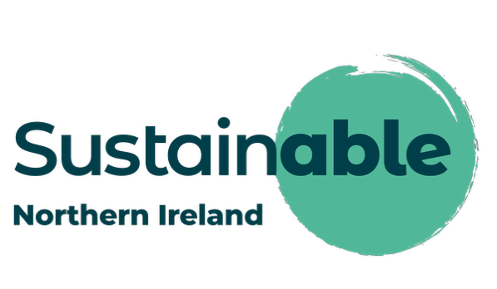

APPLICATION FORM
Assistant Sustainability Adviser
Fixed-Term Contract (to January 2029)
Supported by PEACEPLUS, managed by the Special EU Programmes Body (SEUPB)
Closing Date: 12 noon, Friday 31 July 2026
Please return your completed application to: recruitment@sustainableni.org
Notes on Completion
- This application form is in four parts: Part A (Personal Details), Part B (Essential & Desirable Criteria), Part C (Declaration), and Part D (Equal Opportunities Monitoring).
- Parts A, B and C must be completed in full. It is your responsibility to ensure all relevant parts are completed.
- Part B (the criteria section) is the main basis for shortlisting. Please give specific, detailed examples that demonstrate your own personal role and experience — general statements, job titles or lists of duties will not be sufficient evidence on their own.
- Completion of Part D (Equal Opportunities Monitoring) is voluntary and the information will be used for monitoring purposes only; it will not be seen by the shortlisting panel.
- Applicants must have the right to work in the UK.
- Please retain a copy of your completed application for your own records.
- Alternative formats of this application form are available on request.

Part A: Personal Details
Surname:
First Name(s):
Title:
Address:
Postcode:
Telephone/Mobile:
Email Address:

Do you have the right to work in the UK? | Yes | No

How did you hear about this role?
Sustainable NI website |  | LinkedIn
NI Jobs / job board (please specify) |  | Word of mouth
Social media (please specify) |  | Other (please specify)

Interviews are anticipated to take place w/c 31st August 2026 (subject to change). Please indicate below any dates you are unavailable for interview during this period. We will seek to facilitate availability where possible, but this may not be guaranteed.

Part B: Essential & Desirable Criteria
This section is the main basis on which shortlisting decisions will be made. Please provide specific, detailed examples that demonstrate your own personal experience and ability against each criterion. General statements, job titles, or lists of duties and responsibilities will not, by themselves, be regarded as sufficient evidence. Candidates who do not clearly evidence each essential criterion will not be progressed to interview.
Criterion 1 – Qualification
Essential: A degree in Sustainability, Environmental Science, Public Policy, Planning, Engineering, or a related field.
Degree title:
Institution:
Year obtained:

Criterion 2 – Subject Matter Knowledge of Climate Change and Sustainability
Essential: Understanding of sustainable development principles and related policy or regulatory frameworks relevant to climate change and sustainability.
Please provide an example that demonstrates your knowledge in this area. Maximum 400 words.

Criterion 3 – Communication and Engagement
Essential: Strong written and verbal communication skills, with the ability to draft reports, briefings, and stakeholder communications for diverse audiences.
Please provide an example that demonstrates this. Maximum 400 words.

Criterion 4 – Critical Thinking and Analysis
Essential: Ability to critically evaluate information from a range of sources and apply logical reasoning to develop practical solutions.
Please provide an example that demonstrates this. Maximum 400 words.

Criterion 5 – Organisation and Teamwork
Essential: Ability to work collaboratively in a small team, manage time effectively, work flexibly and balance multiple tasks and projects.
Please provide an example that demonstrates this. Maximum 400 words.

Desirable Criteria
The following criteria are desirable rather than essential. You do not need to meet all of these to be considered, but please provide brief details of any that apply to you.
I have a minimum of one year's professional experience in an industry relevant to sustainability
I hold a Master's degree in a relevant discipline
I hold a PhD in a relevant discipline
I have experience managing, promoting, or running events

If you have ticked any of the above, please provide brief details below:

Part C: Declaration
I declare that the information I have given in support of my application, as recorded in Parts A and B of this application form, is true and complete to the best of my knowledge. I understand that a candidate found to have given false information, or to have wilfully suppressed any material fact, will be liable to disqualification or, if appointed, to dismissal.
I confirm that I have the right to work in the UK and will provide evidence of this if required.
Signed:

Date:

Part D: Equal Opportunities Monitoring Information
Sustainable NI is committed to equality of opportunity and to appointment on merit on the basis of ability and aptitude for the role.
Please note that the information you provide on a voluntary basis in this monitoring form will not be available to the selection panel or to anyone else involved in the selection process. The information will be used for monitoring and reporting of statistical information only and will be treated in the strictest confidence.
National Insurance Number
Please enter your National Insurance Number:

Gender
Please select one box | Male | Female

Age
Please give your date of birth:

Community Background
Please indicate your community background by selecting the appropriate box below:
I have a Roman Catholic community background
I have a Protestant community background
I have neither a Protestant nor Roman Catholic community background

Disability
The Disability Discrimination Act (DDA) defines a disability as a “physical or mental impairment which has substantial and long-term adverse effect on a person’s ability to carry out normal day-to-day activities”.
Do you consider yourself to have a disability?
Please select one box | Yes | No

Race
Please select one box to indicate your race:
 | White |  | Black African
 | Black Caribbean |  | Bangladeshi
 | Chinese |  | Black Other
 | Pakistani |  | Indian

Are you a member of a Mixed Ethnic Group?
Please select one box | Yes | No

Are you a member of the Irish Travelling Community?
Please select one box | Yes | No

If you are of other ethnic origin, please specify:

Language
Is English your first language? (Please select one box below):
Please select one box | Yes | No

Sexual Orientation
Please consider the statement below and select one box: My sexual orientation is towards someone:
Of the same sex (this covers gay men and lesbians)
Of a different sex (this covers heterosexual men and women)
Of the same sex and of the opposite sex (this covers bisexual men and women)

Marital Status
Please indicate your marital status by selecting one box below:
Single, that is never married or in a civil partnership
Married
Separated, but still legally married
Divorced
Widowed
In a civil partnership
Separated, but still legally in a civil partnership
Formerly in a civil partnership which is now legally dissolved
Surviving partner from a civil partnership

Dependants
Do you have personal responsibility for the care of a child, or children, a person with a disability or a dependent older person?
Please select one box | Yes | No

Additional Information
Which sector would you consider best reflects your employment history over the course of your career?
 | Private Sector |  | Other Public Sector
 | Civil Service |  | Voluntary Sector

Other, please specify:

What is your highest level of educational attainment?
 | No Qualifications |  | A-level or equivalent
 | GCSE / O-level or equivalent |  | Degree or higher

Thank you for completing this application form.

